Name : Saurabh Sanjay Jadhav

Topic : Git clone & git fork

Assignment no. : 2

1. Create EC2 instance of ubuntu OS. Connect to EC2 instance

**Cloning :**

1. Clone the git repository of another user. Check the files of repository.

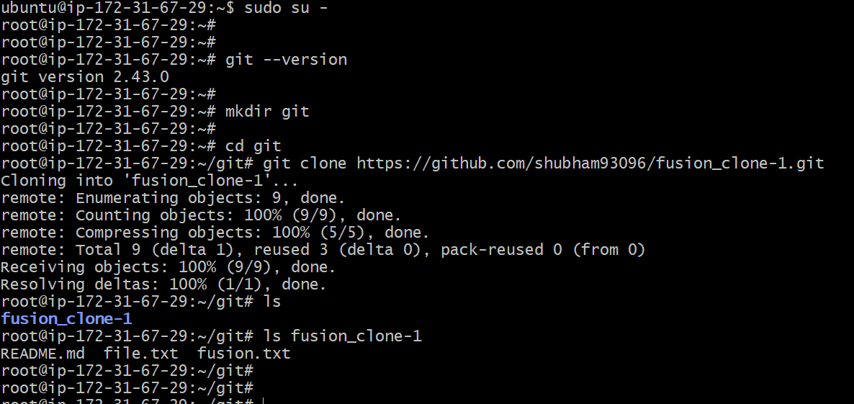

1. Create new repo in github.

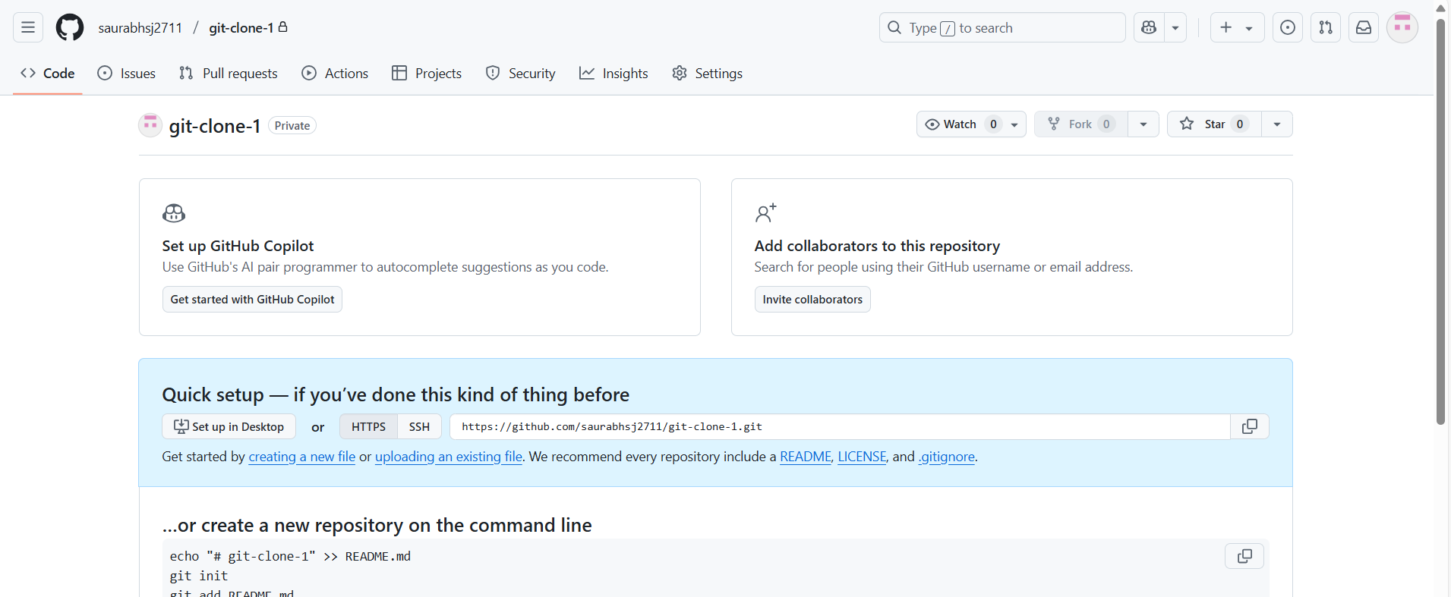

1. To add another origin master.
2. Rm -rf .git --🡪 remove .git directory
3. Git init ---------> initialize git
4. Git remote add origin <repo-link> -----------> add git our new repo

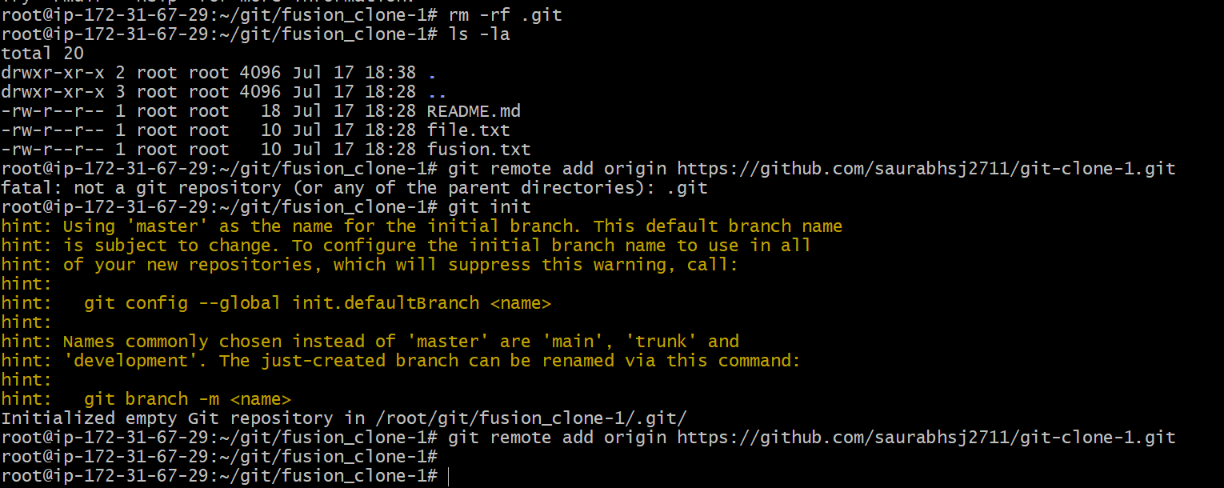

1. Add the cloned repo to local repo
2. Git add .
3. Git commit -m “Copy another repo”

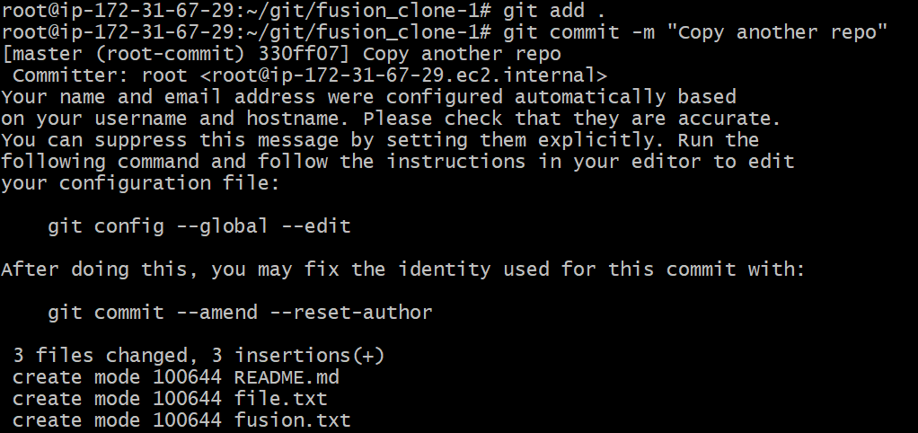

1. Push the local repo to remote repo.

Git push origin master

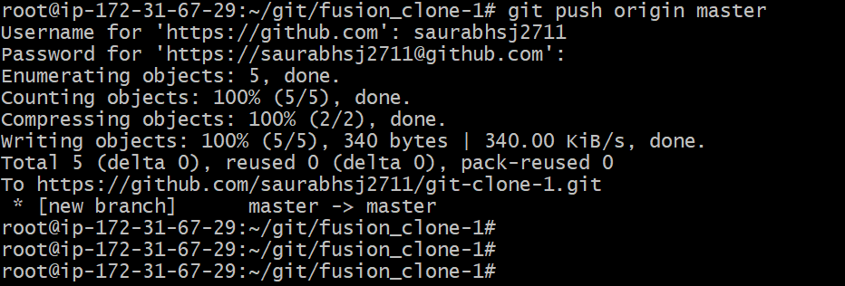

**Forking :**

1. Navigate to another user repo. Create fork of it.

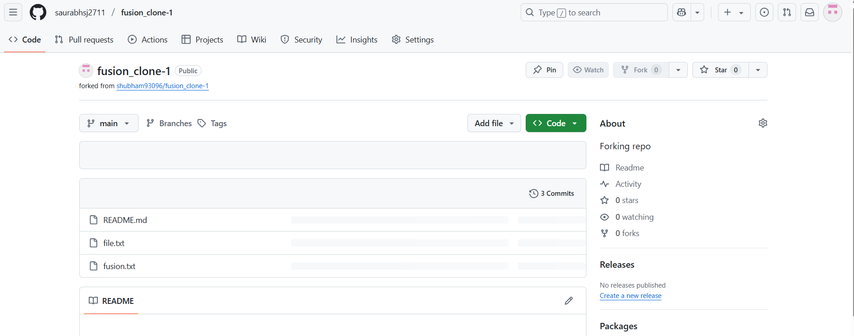

1. Successfully created forked repo .

